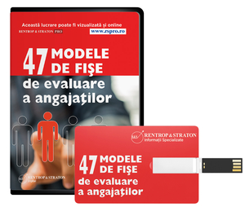
Cuprins
- Administrator imobile
- Administrator sala de sport
- Administrator societate
- Afumator carne (peste)
- Agent de securitate
- Agent vanzari
- Agricultor in culturi vegetale si crescator de animale
- Ambalator manual
- Analist financiar
- Asistent farmacist
- Asistent manager
- Asistent medical studii superioare
- Asistent social nivel superior
- Asistent veterinar
- Bibliotecar studii superioare
- Casier
- Consilier in management
- Consultant in management
- Contabil sef
- Coordonator serviciu caini fara stapan
- Director comercial
- Director director adjunct inspector sef si asimilati
- Director general
- Director general societate comerciala
- Director vanzari
- Economist
- Educatoare
- Electrician de intretinere si reparatii
- Expert accesare fonduri structurale si de coeziune europene
- Farmacist
- Farmacist Diriginte
- Inginer economist
- Inginer electromecanic
- Inginer electrotehnist
- Inginer in industria alimentara
- Inginer mecanic
- Inginer zootehnist
- Inspector asigurari
- Inspector protectia mediului
- Inspector referent resurse umane
- Investigator
- Jurisconsult
- Jurnalist
- Jurnalist de investigatii
- Lucrator comercial
- Macaragiu
- Maistru energetician
- Manager achizitii
- Manager farmacie
- Manager financiar
- Manager marketing tarife contracte achizitii
- Manager proiect
- Manager resurse umane
- Mecanic utilaj
- Medic veterinar
- Menajera
- Muncitor necalificat in constrctii
- Organizator de conferinte si evenimente
- Peisagist
- Prinzator de caini
- Profesor in invatamantul liceal postliceal profesional si de maistri
- Referent de specialitate forta de munca si somaj
- Reprezentant comercial
- Responsabil protectia datelor cu caracter personal
- Secretar asistent director
- Secretara
- Sef birou serviciu administrativ
- Sef departament logistica
- Sofer de autoturisme si camionete
- Specialist in relatii publice
- Sudor
- Tehnician Merceolog

